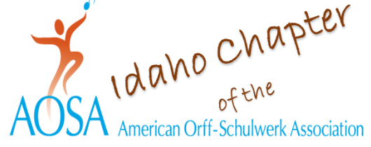
September 5, 2023

Dear Parents,

I would like to tell you about a wonderful musical opportunity coming your child’s way in February of 2024!

Idaho Orff and Idaho Music Educators Association are welcoming back the Elementary Orff Ensemble to the 2024 IMEA Professional Development Conference at Northwest Nazarene University in Nampa, February 1-3, 2024! The directing team of Orff Specialists David Thaxton from Reno, Nevada, and Ardith Collins of New York City, will be singing, speaking, moving, and playing with elementary students, 4th – 6th grades, Thursday and Friday, February ^{1st} and 2nd with a performance on Saturday morning, February 3.

Interested students should be able to match pitch and keep a steady pulse and must be recommended by their music teacher. Students from around the state, outside of the Treasure Valley area, will be welcomed but must be housed locally with a parent or guardian in area hotels or with family/friends in the area.

Idaho Orff and IMEA leaders are anxious to bring the creativity of the Orff Schulwerk process to the music educators of Southwestern Idaho. Student participation along with teacher observations of the rehearsals and Orff Specialists’ techniques and strategies will be a win-win experience for your child and for your child’s elementary music teachers.

What is Orff Schulwerk and why should my child become involved? This is a great question! The Orff approach to the teaching of music to children is based in the rhythms of language and is an active approach to music making that includes speech, singing, moving, playing instruments that are used in the Orff process (xylophones, drums, recorders, etc.) and creating. During our Orff Ensemble rehearsals, our students will create the movements they use to accompany their singing and speaking. Creating is a crucial 21st century skill.

Your students and music educator will need your support in attending the ensemble rehearsals on Thursday and Friday, February 1 and 2, and we would love to have you join us for the performance on Saturday morning, February 3. You are also welcome to attend any of the rehearsals as well so that you may see the active, creative, energetic process in person. We will keep you informed of the itinerary as we near those dates.

Student fees for this All-State opportunity are $155 and include lunch, snacks, necessary music, and the Idaho Orff/ IMEA Elementary Ensemble T Shirt. Registration will begin soon with registration forms due on October 30, and fees due on November 30. You can sign your child up for this event on the Idaho Orff website at www.idahoorff.org. If your school PTO has funds available that they are looking to spend wisely, this could be an opportunity to include students who may not have the financial means to attend on their own.

Should you have any questions about this opportunity for your child, please contact one of our 2024 Idaho Orff/IMEA Elementary Orff Ensemble team members below.

Warm Regards,

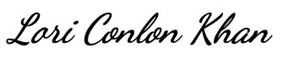

Dr. Lori Conlon Khan
Music Education Professor
University of Idaho

Lori Conlon Khan – lorick@uidaho.edu
Shirley VanPaepeghem – svanpaepeghem@nnu.edu
Miranda Rupp – miranda.rupp@boiseschools.org
Falane Gerritsen – Gerritsen.Falane@westada.org

