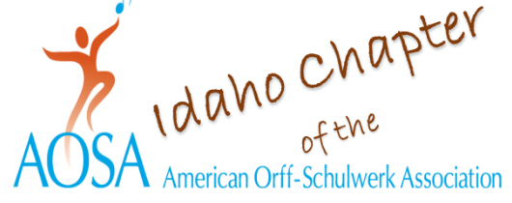
September 5, 2023

Dear Music Student,

We would like to tell you about a wonderful musical opportunity coming your way in February of 2024!

Two music teachers’ groups, Idaho Orff and the Idaho Music Educators Association, are welcoming back the Elementary Orff Ensemble to the 2024 IMEA music teacher’s meeting at Northwest Nazarene University in Nampa, February 1-3. This is a group of elementary kids from all around the state that come together to sing, speak, play instruments, and create cool movements to go along with their music. The directing team of music teachers David Thaxton from Reno, Nevada, and Ardith Collins of New York City, will be singing, speaking, moving, and playing instruments with kids your age, 4th – 6th graders, Thursday and Friday, February 1st and 2nd with a performance on Saturday morning, February 3, for your parents and friends!

If you like to sing, move, create, and play instruments this opportunity is for you! You will need to be recommended by your music teacher because we want to know that you will be able to work in a group. Kids from all around the state will be coming to join in this special musical team!

You will be at the ensemble rehearsals on Thursday and Friday, February 1 and 2, so we must plan way in advance. You and your parents will need to let your classroom teacher know that you will be absent from school. We will have lots of music making and moving, but we will also have a few breaks to visit with friends. Lunch and snacks will be provided for you, plus a cool T shirt to wear for the performance! It does cost some money to participate, so be certain to talk to your parents if you are interested and have them read their letter from us.

We hope to see you in February! It will be an awesome event and something you will remember for always.

Sincerely,

Lori Conlon Khan – lorick@uidaho.edu
Shirley VanPaepeghem – svanpaepeghem@nnu.edu
Miranda Rupp – miranda.rupp@boiseschools.org
Falane Gerritsen – Gerritsen.Falane@westada.org

